The Search and Rescue Assistant (SRA) is designed to be a simple to use system to aid search and rescue efforts by mapping in detail areas that have been searched, areas that need to be searched, areas that are off limits to volunteer groups, and the locations of search and rescue teams. This system would give search and rescue commanders more control over operations, decrease the number of mistakes made, and generally speed up the search and rescue process.

The system consists of three main components, the Rescue Field Device (RFD), the Signal Transmitter Receiver (STR), and the SRA desktop program. The system works by having the RFDs and the SRA program communicate with each other through the STR. They would send information such as GPS locations or short messages allowing personal in the field to quickly update the operations commander on their location and status. This communication will be facilitated by the STR which will be in charge of translating the information received from the RFDs for the SRA program. Figure 1 shows a diagram of what the user would see when using the program and figure 2 shows what the user would see when using the RFD.

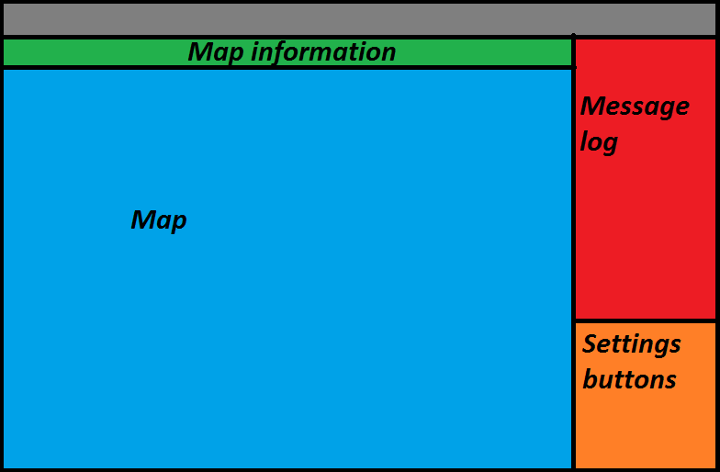  
*Figure 1*

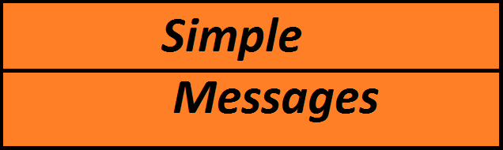

*Figure 2*

Let’s run through an example of how the system would be used by search and rescue personal. When a search is set up the commander of the search sets up a base camp to house the computers and radio equipment and to be used as a place for personal to eat and rehydrate. When they are setting up the search, the commander would plug in the STR into a computer and start up the program. Once started, all of the panels would be empty except the settings panel which would have a single button, the ‘start new operation’ button. After clicking this button, the program would have a dialoge box appear with a drop down menu asking the commander to select the number of teams that are part of this search and rescue operation. It would then require the unique ID of each RFD that will be used in the search as well as the name of the team, the number of people in that team and the color that is associated with that team. This information would be put into dialogue boxes that appear. After inputting all that information the commander would type in the GPs coordinates of home base in a final dialogue box. The program would figure out from its list of stored maps what map contains that GPS coordinate and display that map to the user in the map panel. The commander would then click a ‘set up STR’ button in the buttons panel which would check to see if there is an STR and calibrate the device.

Once the receiver has been calibrated a message box will appear telling the user that the receiver has be set up properly. If there was a problem the program will display a warning message. Next it is time to set up the RFDs. Each RFD is turned on and the commander tells the SRA program to send a signal to the RFDs that are part of the search. When an RFD receives this signal it displays a confirmation message on its screen telling the rescue personal that the device is now part of the active search. Should any device not receive a signal for some reason the commander can easily go back one step and change the RFD ID to a different device. They would do this by pressing the ‘change RFD’ button in the button panel.

With all RFDs set up the rescue operation now begins. As teams go out into the field to being searching at certain time intervals, say 20 minutes, a team will press a button on their RFD. The device will then get its current GPS location, display that location to the user and send that information back to the STR. Once the STR has received the information it will send a confirmation signal back to the corresponding RFD. That RFD will then display on its screen a confirmation message so that the user knows they have successfully sent a signal back to the command center. Should the device not establish a signal with the STR it will display a message saying so. This way the user knows they must try and send the signal again.

After the STR has processed the information it will send it to the SRA program which comes up in the messages bar on the right side. This new message would display what team sent the signal, and the time the signal was received. The program will then update the map information by displaying a colored dot on the map that corresponds with the location that was received. The program will then highlight the area between the first dot, which in this case would simply be base camp as it is the start of the search operation, and the second dot. This highlighted area represents the area that has been searched and makes it easy for the commander to keep track of what has and hasn’t been searched. The different colors also will help the commander see at a glance where teams are and if they are veering off course. Areas that cannot be searched will be highlighted in red, this way commanders can tell teams when they are starting to get to close to a restricted area.

When a search team wants to know how much power is left in a device, the team leader can press a second button that will display to the user the percentage of battery life remaining. When the battery power drops below a certain threshold then the device will warn the user that they need to replace its batteries. When a third button is pressed then the device will save information about the current rescue operation on its memory and shut then shut the device down. After the team leader has replaced the batteries they will turn the device back on. If there was a search operation saved on the device, then at startup the device will ask the user if they want to load the search information from memory and continue the search or if they want to scrap the information. If the user chose to continue the search then the device will tell the user it is loading, and after a short amount of time inform the user that all information was loaded. They can then continue with the search operation. This functionality allows the team to operate for hours on end and means they do not have to worry about the device running out of power so long as they have batteries with them. Should the user decide that they want to scrap the current operation the device has saved, then the device will inform the user that it is deleting information, and after a brief period tell them that all the information was successfully deleted.

Once a search operation is over the commander can send a signal to all devices informing the users that they have either found the individual or that the search has been called off. Once at base the users can then simply turn off the devices off as they will not save any information if they received a signal from the STR that the search is over. The commander clicks on the end search button which is located in the ‘settings buttons’ panel. A confirmation box will appear and if the commander clicks on yes then the operation is considered over to the program. It will no longer be looking for information from the STR and it will tell the STR to shut down. After all this has happened, a dialogue box will appear asking if the commander wants to save the information from this operation. If yes the commander can then save to their computer a PDF document that has the map of the area along with the colored dots and highlighted areas. The second page of the PDF will have the key for the map as well as the message log of the operation, showing what happened at what time. The program may then be shut down and the search and rescue personal will begin to pack up base camp.